June 3, 2024

Howdy Friend of the Hall!
The ProRodeo Hall of Fame & Museum of the American Cowboy is excited to announce the dates for our annual Colorado Springs Golf Tournament, Cowboy Ball with silent auction, and Induction Ceremony. The 36th Annual Golf Tournament will take place on July 11th, and our Cowboy Ball, the kick-off event to Induction Weekend as well as an annual fundraising event for the Hall, is scheduled for July 12th, followed by our Hall of Fame Induction Ceremony on Saturday, July 13th.

There are several ways you can support the Golf Tournament, Cowboy Ball, and Induction Ceremony. We offer varying levels of sponsorship packages for each event and have attached lists for each event for your review. You can also support the Cowboy Ball, which typically draws over 400 people from around the United States and is an evening where the rodeo community gathers to celebrate the individuals being inducted into the ProRodeo Hall of Fame, by donating an item or service to our auction. By donating, you will assist us in making our event a success! Your donation will be a tax-deductible contribution that will help the ProRodeo Hall of Fame, a 501-c-3 educational institution, to continue to preserve and promote the history of Professional Rodeo. If you are interested in supporting the Golf Tournament through a donation, we are also accepting items and services for the Tournament’s Raffle, and items for the Golfer Goodie Bags.

Please consider being a sponsor of one of the ProRodeo Hall of Fame Induction Events or donating an item or service to support the continued efforts of the ProRodeo Hall of Fame. If you are donating an item or service, please fill out the Donation Form. We ask that donations are received by July 5th.

For more information regarding our Induction Events, please feel free to contact me. I look forward to seeing your business represented.

If you are interested in attending this year’s Cowboy Ball, or registering in the Colorado Springs Golf Tournament, please contact me for ticket and registration information. Information is also available on our website, where you may also purchase tickets or sponsorships and register for golf. Please visit www.ProRodeoHallofFame.com.

I hope you might consider partnering with us by supporting the ProRodeo Hall of Fame. We truly appreciate any support you might be able to offer.
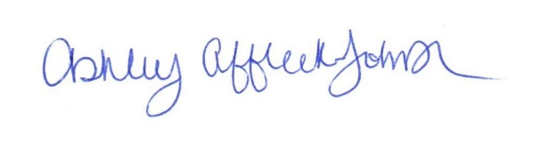
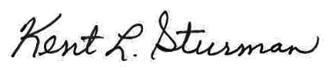
Sincerely,

Ashley Affleck-Johnson Kent Sturman
Marketing, Membership & Events Supervisor ProRodeo Hall of Fame Director
719.528.4732 | AJohnson@prorodeo.com

